**Project Report**

# Construction Project Management System Portal

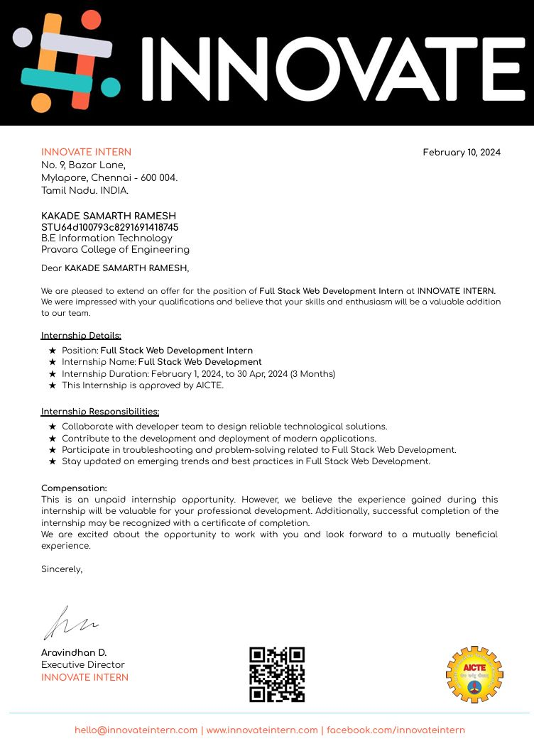

# Innovate Intern

### **Project Title:** **Construction Project Management System (PMS) Portal**

### **Date:** **[21-06-2024]**

**Prepared By:**

**Your Name : LAKSHMI PRAVALLIKA CHODY**

**Your Title : CONSTRUCTION PROJECT MANAGEMENT SYSTEM**

**Your Domain : Full Stack web development**

**Technologies used : HTML ,CSS , JAVASCRIPT , PHP , MY SQL , BOOTSRAP , AND FRAMEWORKS**

**Submitted To:**

**Client Company : INNOVATE INTERNS**

**Submission Date : 21-06-2024**

**Project Status : Completed working and testing , and Executing in a good status.**

Table of Contents

1. Introduction

2. Project Overview

3. Features

- Dashboard

- Employee List

- Project List

- Users

- Maintenance

- Position

- Project Divisions

- Project Team

4. User Access and Roles

- Admin Access

- Worker Access

5. Security Measures

6. System Design and Architecture

- Frontend

- Backend

- Database Structure

7. User Interface and Experience

8. Reporting and Analytics

9. Real-time Notifications

10. Document Management

11. Integration with Third-party Tools

12. Performance Optimization

13. Backup and Recovery

14. Conclusion

1. Introduction

The Construction Project Management System (PMS) portal is a robust, web-based solution designed to streamline project management processes in the construction industry. Leveraging modern web technologies like HTML, CSS, JavaScript, PHP, SQL, and Bootstrap, this portal offers a comprehensive suite of features to facilitate efficient management of construction projects, from inception to completion. The portal is designed to cater to both administrators and workers, ensuring a seamless flow of information and efficient project tracking.

2. Project Overview

The PMS portal is an all-in-one solution for managing construction projects. It allows users to store and retrieve detailed construction data, monitor daily project progress, and manage various aspects of the project lifecycle. The portal is equipped with a dynamic dashboard, detailed employee and project lists, user management capabilities, and features for maintenance tracking. Additionally, it provides tools for managing job positions, project divisions, and project teams. By integrating real-time notifications, document management, and reporting and analytics features, the PMS portal aims to enhance project efficiency, improve communication, and ensure successful project delivery.

3. Features

Dashboard

The Dashboard serves as the central hub for project management, providing a real-time overview of all ongoing projects. It includes visual elements such as bar charts, pie charts, and progress bars to represent key metrics like project completion percentages, deadlines, and resource allocation. The dashboard allows users to quickly assess the status of multiple projects, identify potential issues, and make informed decisions.

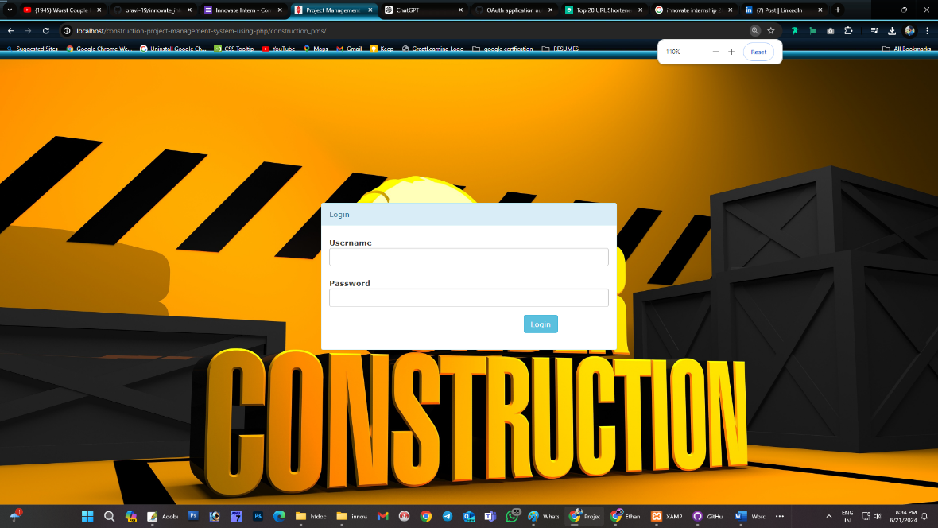

Employee List

The Employee List feature enables administrators to manage detailed records of all employees. It includes personal information, job roles, contact details, and work history. Administrators can add new employees, update existing records, and remove employees who are no longer with the organization. This feature ensures that the workforce database is always up-to-date and provides a centralized location for managing employee information.

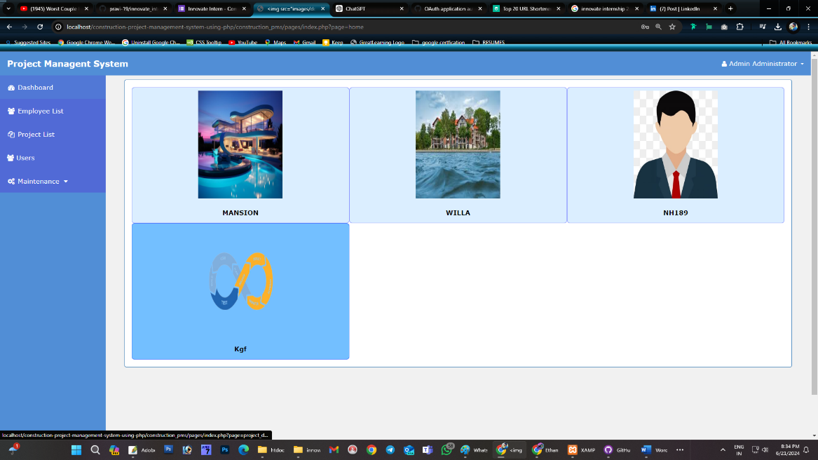

Project List

The Project List feature provides a comprehensive overview of all projects within the system. Each project entry includes a detailed description, start and end dates, current status, assigned team members, and progress reports. Users can filter and sort projects based on various criteria, such as project type, deadline, or status, to easily manage and track multiple projects simultaneously.

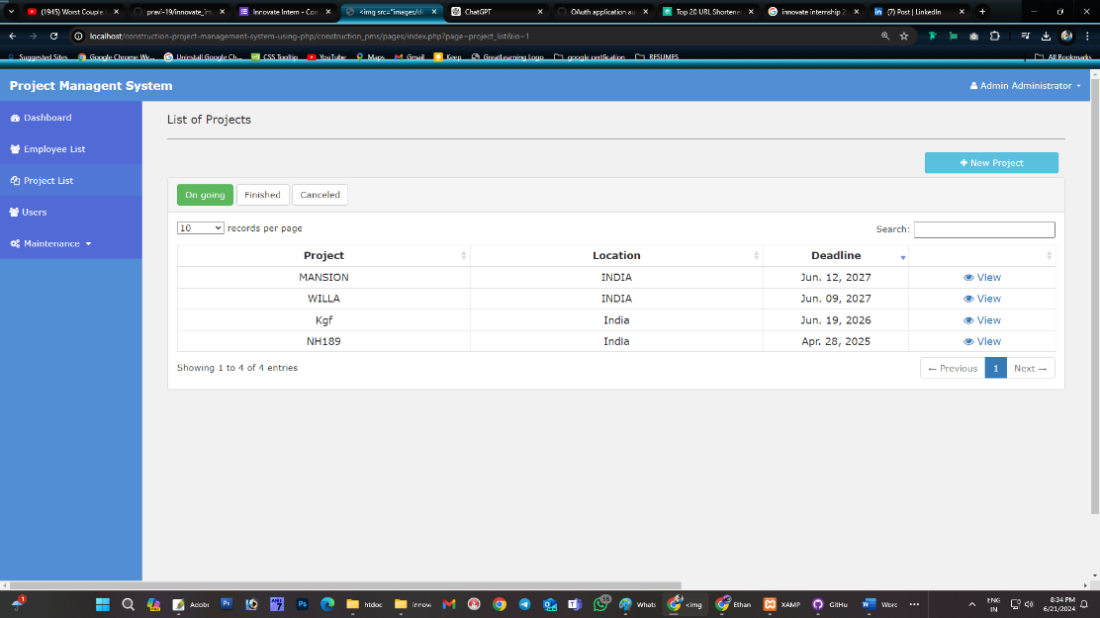

Users

The Users module handles user account management, including registration, login, and role assignment. It ensures that only authorized personnel can access specific features and data within the portal. Admins can create and manage user accounts, assign roles and permissions, and deactivate accounts as needed. This module plays a crucial role in maintaining the security and integrity of the system.

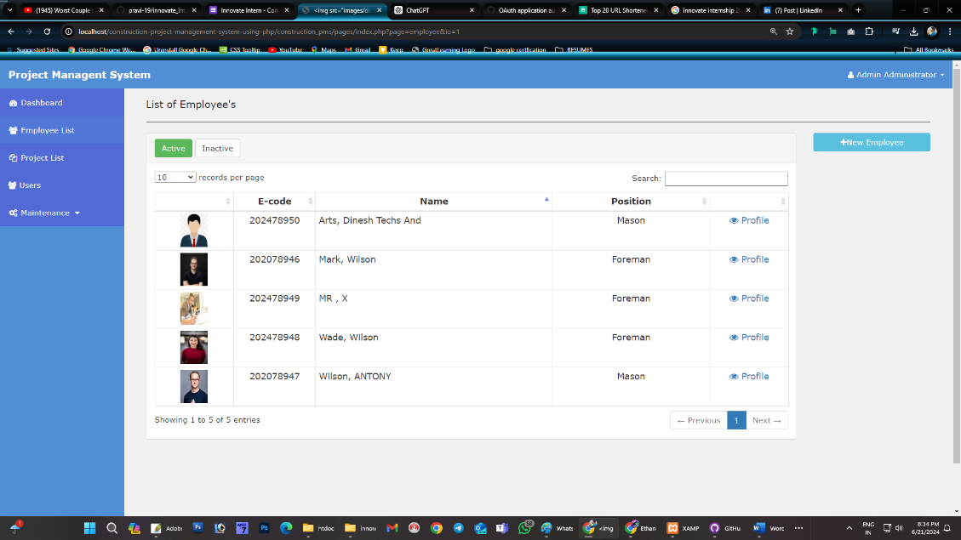

Maintenance

The Maintenance feature tracks all maintenance activities related to equipment and site infrastructure. It allows users to log maintenance tasks, schedule regular maintenance, and record details of performed maintenance activities. This feature helps ensure that all equipment is in optimal working condition, minimizing downtime and preventing project delays due to equipment failure.

Position

Position management involves defining job roles and responsibilities within the organization. This feature helps in assigning specific tasks to employees based on their roles and expertise. It allows administrators to create and manage job positions, assign employees to positions, and ensure that all roles are adequately staffed.

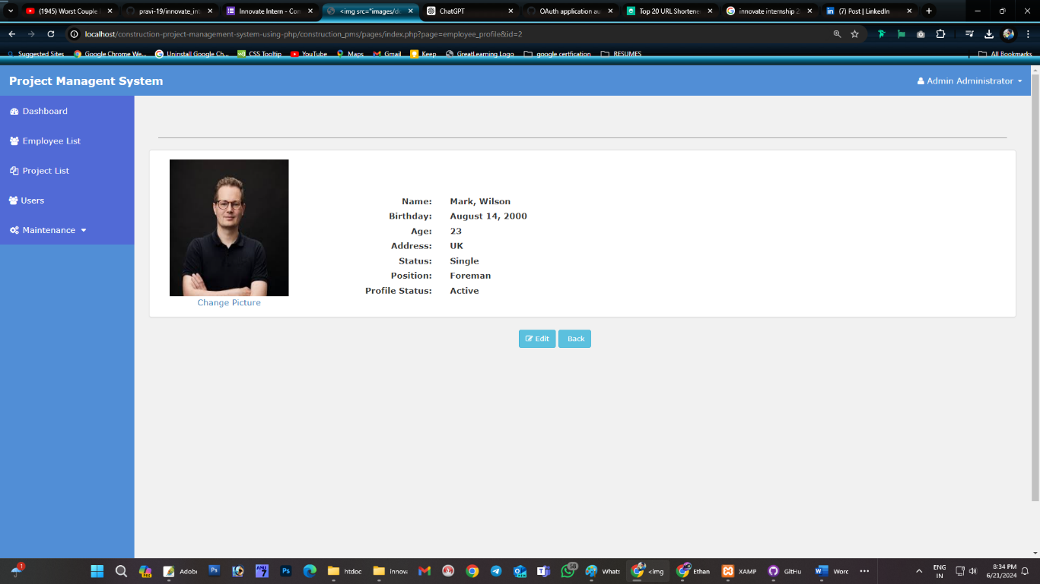

Project Team

The Project Team management feature enables the assignment of team members to specific projects or divisions. It includes tracking team member availability, roles, and responsibilities, ensuring efficient team coordination. This feature allows administrators to build effective project teams, monitor team performance, and ensure that all team members are working towards common project goals.

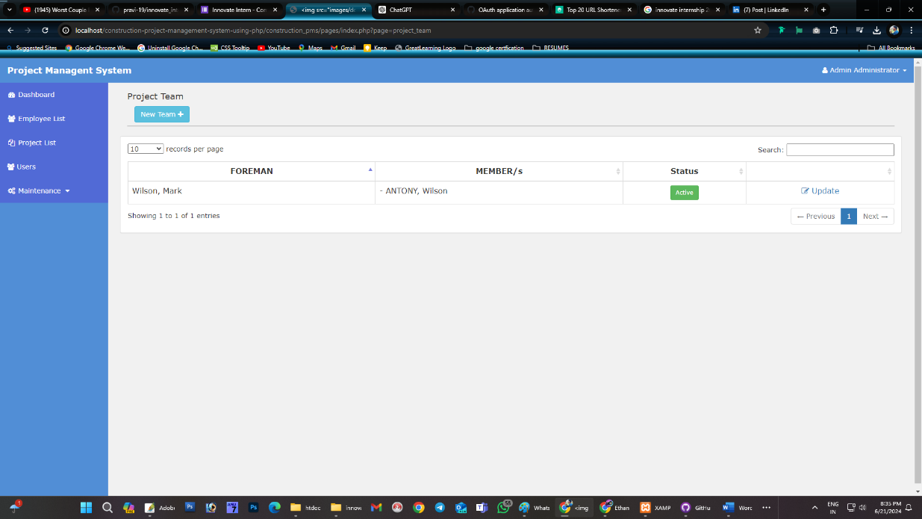

Project Divisions

The Project Divisions feature allows for the organization of large projects into smaller, manageable sections. Each division can be tracked and managed independently, providing a detailed view of each phase of the project. This feature helps in breaking down complex projects into more manageable parts, ensuring comprehensive oversight and easier tracking of project progress.

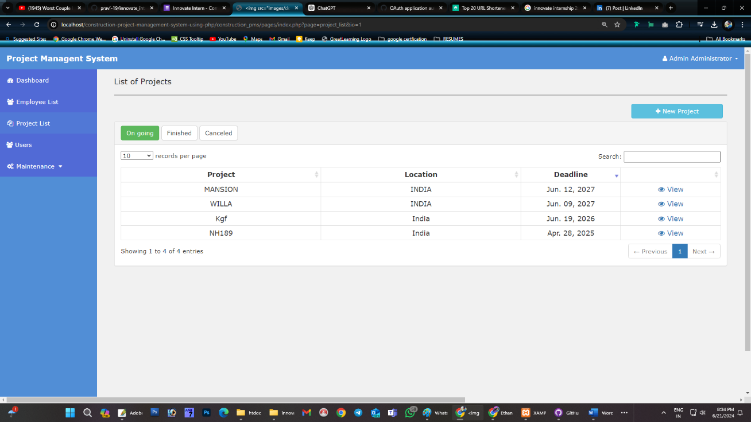

4. User Access and Roles

Admin Access

Admins have full access to all features of the portal. They can manage users, projects, and employees, generate reports, and perform maintenance tasks. Admins also have the authority to assign roles and permissions to other users. This level of access ensures that admins can oversee and manage all aspects of the portal, ensuring smooth operation and effective project management.

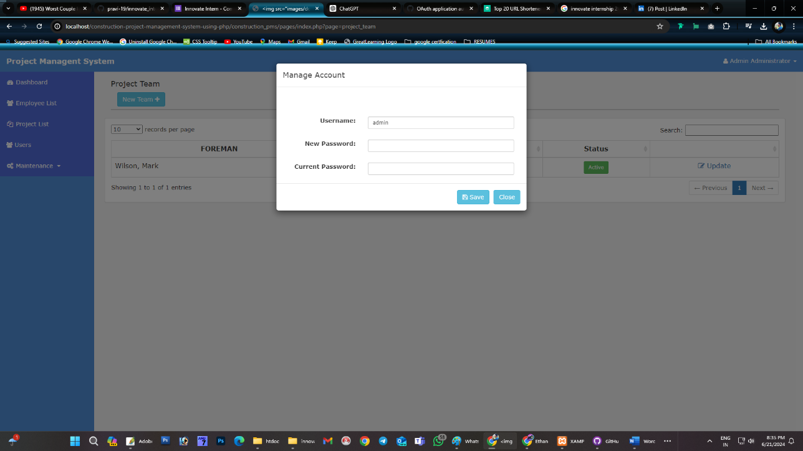

Worker Access

Workers have restricted access, limited to viewing and updating their assigned tasks, logging progress, and accessing project-related documents. They can view project details relevant to their work but cannot alter critical project or employee data. This level of access ensures that workers have the information they need to perform their tasks without compromising the security and integrity of the system.

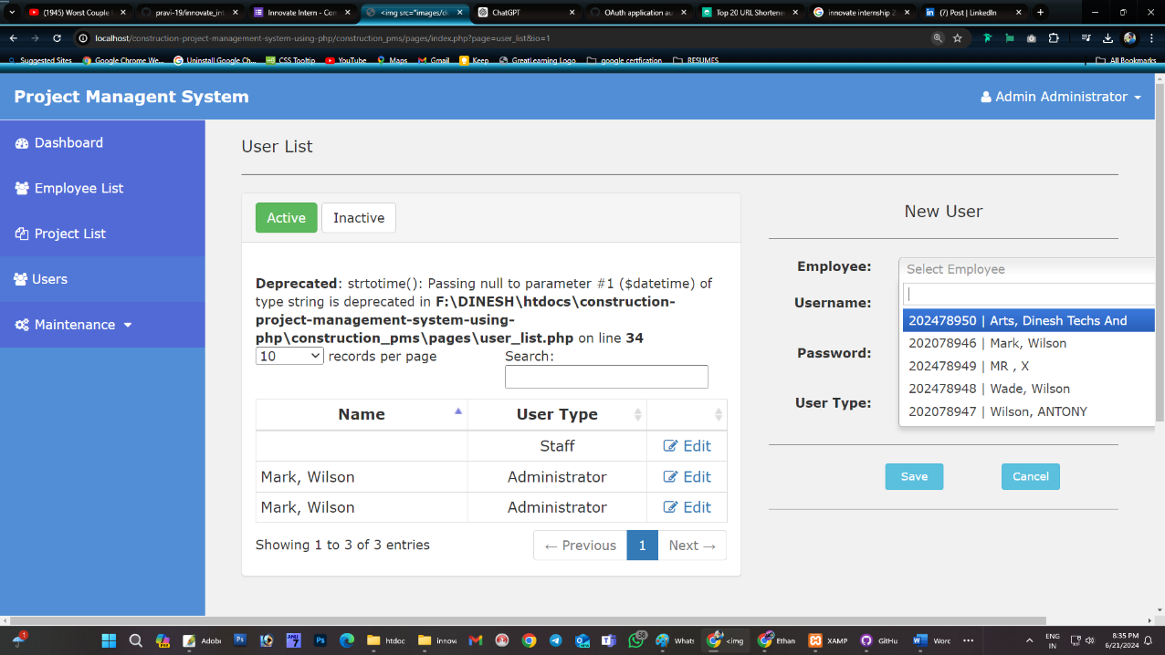

5. Security Measures

The portal incorporates multiple security measures to protect user data and prevent unauthorized access. These measures include secure login with encryption and hashing for passwords, role-based access control to restrict data access, and regular security audits and updates to protect against vulnerabilities. Additionally, the system logs all user activities, providing a detailed audit trail that can be reviewed in case of security incidents.

6. System Design and Architecture

Frontend

The frontend of the PMS portal is built using HTML, CSS, Bootstrap, and JavaScript. This combination of technologies ensures a responsive and user-friendly interface that works well on various devices and browsers. The use of Bootstrap helps in creating a consistent and professional design, while JavaScript adds interactivity and enhances the user experience.

Backend

The backend of the portal is powered by PHP, handling server-side logic, database interactions, and user authentication. PHP provides a robust and flexible platform for building dynamic web applications, ensuring efficient data processing and secure transaction handling.

Database Structure

The database is structured using SQL, with tables for users, employees, projects, maintenance records, positions, and project divisions. Relationships between tables are defined to maintain data integrity and support complex queries. The database design ensures efficient storage and retrieval of data, supporting the various features of the portal.

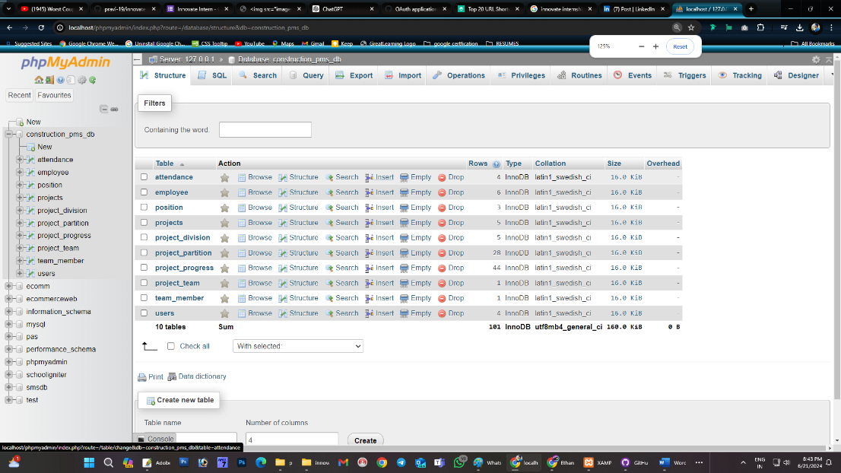

7. User Interface and Experience

The user interface of the PMS portal is designed for simplicity and efficiency. Key features include intuitive navigation, consistent design elements, and responsive layouts. The use of modern web design principles ensures that the portal is easy to use, even for users with limited technical knowledge. Regular user feedback is gathered and incorporated into design updates to continuously improve the user experience.

8. Reporting and Analytics

The reporting and analytics features of the portal provide users with powerful tools to generate detailed reports on project progress, employee performance, and resource allocation. Graphical representations, such as charts and graphs, help in visualizing data trends and identifying areas for improvement. Users can customize reports to focus on specific metrics, providing valuable insights for decision-making.

9. Real-time Notifications

Real-time notifications keep users informed about critical updates, deadlines, and changes in project status. Notifications can be configured to appear as pop-ups, emails, or SMS alerts, ensuring timely communication. This feature helps in improving communication and coordination among team members, ensuring that everyone is aware of important developments.

10. Document Management

The document management feature allows users to upload, store, and organize essential project documents, including blueprints, contracts, and reports. It supports various file formats and ensures secure document handling and access. Users can categorize documents, set access permissions, and track document versions, ensuring that all project-related documents are easily accessible and up-to-date.

11. Integration with Third-party Tools

The portal supports integration with third-party tools, such as email services, cloud storage solutions, and project management or accounting software. This ensures seamless data exchange and enhanced functionality. For example, integration with cloud storage solutions allows users to access project documents from anywhere, while integration with accounting software helps in tracking project expenses and budgets.

12. Performance Optimization

Performance optimization techniques are implemented to handle large datasets efficiently. These include database indexing, query optimization, and server-side caching. Regular performance testing ensures that the portal remains fast and responsive, even under heavy load. These optimizations help in providing a smooth user experience and ensuring that the portal can scale to meet the needs of large construction projects.

13. Backup and Recovery

The system includes a comprehensive backup and recovery plan to protect against data loss. Regular backups are performed, and recovery procedures are in place to restore data in case of corruption or accidental deletion. The backup plan includes both on-site and off-site backups, ensuring that data can be recovered even in the event of a major disaster.

14. Conclusion

The Construction Project Management System portal is a robust and versatile tool designed to enhance project management in the construction industry. With its comprehensive features, secure user access, and real-time tracking capabilities, it significantly improves project efficiency and oversight. The portal provides a centralized platform for managing all aspects of construction projects, from employee and project management to maintenance tracking and document management. By integrating powerful reporting and analytics tools, real-time notifications, and robust security measures, the PMS portal ensures successful project execution from start to finish.

Appendices

Appendix A: Screenshots

Included various screenshots of the portal, showcasing the dashboard, employee list, project list, user management, and other key features.